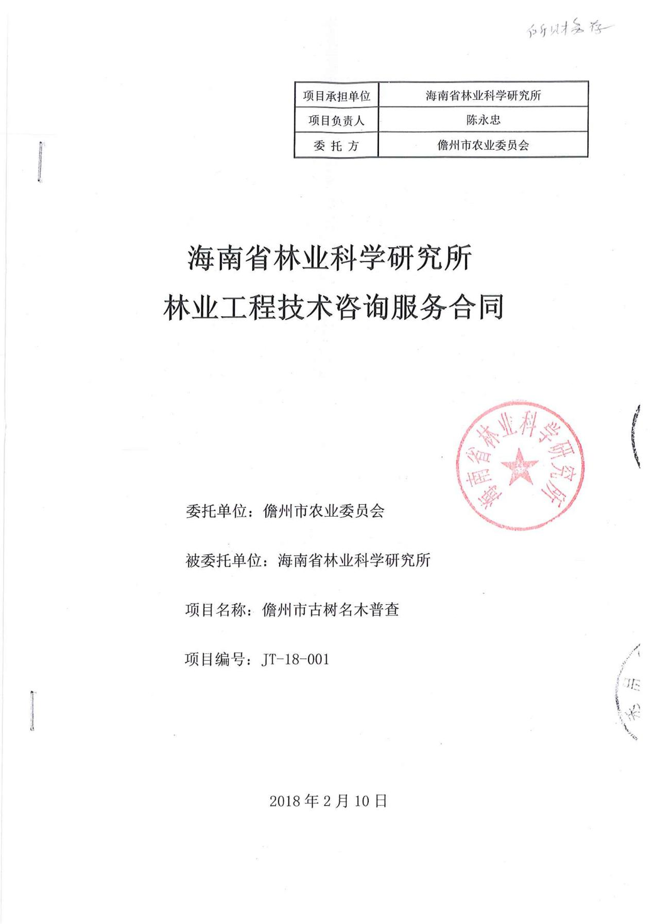

20180301145430959_0006

20180301145430959_0007

20180301145430959_0008